Ответственные:
oraDBA Бугров
Unix Белогруд
Apps Мостовой
Место проведения работ:
XXI/XXI_MFO
Описание работ:
Перезагрузка XXI/XXI_MFO на второй узел кластера с перемещением TEMP на FLASH карту
Технические детали:

DS-DB23-PROD2
M1-DB23-DR
---
UNIX - перемонтировать
/dev/nvme1n1p1 -> /oramnt/flash/temp
DBA - создать директории
/oramnt/flash/temp/XXI_MFO
/oramnt/flash/temp/XXI

01:30 XXI_MFO
---
APPS Отмашка на начало работ
UNIX Правят режим старта базы на CUSTOM
UNIX Создают на целевом сервере (ds-db23-prod2) файл

cat /opt/VRTSagents/ha/bin/Oracle/start_custom_XXI_MFO.sql
startup mount

UNIX запускают переезд базы
DBA переименовывают TEMP файлы

select open_mode from v$database;

alter database rename file '/oramnt/XXI_MFO_prod_di01/temp001.dbf' to '/oramnt/flash/temp/XXI_MFO/temp001.dbf';

select name from v$tempfile;

DBA открыть БД

alter database open;

ls –l /oramnt/flash/temp/XXI_MFO
tail -100f /opt/oracle/diag/rdbms/xxi_mfo_n/XXI_MFO/trace/alert_XXI_MFO.log

UNIX в настройках Veritas нужно поменять режим старта на STARTUP
APPS проверяют работу системы

02:00 XXI
---
DBA Изменить параметры экземпляра
alter system set sga_max_size = 2640G scope = spfile;
alter system set sga_target = 0 scope = spfile;
alter system set db_cache_size = 2570240M scope = spfile;
alter system set shared_pool_size = 70G scope = spfile;
alter system set streams_pool_size = 6G scope = spfile;
alter system set java_pool_size = 4G scope = spfile;
alter system set result_cache_max_size = 2G scope = spfile;

APPS Отмашка на начало работ
UNIX Правят режим старта базы на CUSTOM
UNIX Создают на целевом сервере (ds-db23-prod2) файл

cat /opt/VRTSagents/ha/bin/Oracle/start_custom_XXI.sql
startup mount

UNIX запускают переезд базы
DBA переименовывают TEMP файлы

select open_mode from v$database;

alter database rename file '/oramnt/flash/XXI_prod_temp/temp020.dbf' to '/oramnt/flash/temp/XXI/temp020.dbf';
alter database rename file '/oramnt/flash/XXI_prod_temp/temp019.dbf' to '/oramnt/flash/temp/XXI/temp019.dbf';
alter database rename file '/oramnt/flash/XXI_prod_temp/temp018.dbf' to '/oramnt/flash/temp/XXI/temp018.dbf';
alter database rename file '/oramnt/flash/XXI_prod_temp/temp017.dbf' to '/oramnt/flash/temp/XXI/temp017.dbf';
alter database rename file '/oramnt/flash/XXI_prod_temp/temp016.dbf' to '/oramnt/flash/temp/XXI/temp016.dbf';
alter database rename file '/oramnt/flash/XXI_prod_temp/temp015.dbf' to '/oramnt/flash/temp/XXI/temp015.dbf';
alter database rename file '/oramnt/flash/XXI_prod_temp/temp014.dbf' to '/oramnt/flash/temp/XXI/temp014.dbf';
alter database rename file '/oramnt/flash/XXI_prod_temp/temp013.dbf' to '/oramnt/flash/temp/XXI/temp013.dbf';
alter database rename file '/oramnt/flash/XXI_prod_temp/temp012.dbf' to '/oramnt/flash/temp/XXI/temp012.dbf';
alter database rename file '/oramnt/flash/XXI_prod_temp/temp011.dbf' to '/oramnt/flash/temp/XXI/temp011.dbf';
alter database rename file '/oramnt/flash/XXI_prod_temp/temp008.dbf' to '/oramnt/flash/temp/XXI/temp008.dbf';
alter database rename file '/oramnt/flash/XXI_prod_temp/temp007.dbf' to '/oramnt/flash/temp/XXI/temp007.dbf';
alter database rename file '/oramnt/flash/XXI_prod_temp/temp010.dbf' to '/oramnt/flash/temp/XXI/temp010.dbf';
alter database rename file '/oramnt/flash/XXI_prod_temp/temp009.dbf' to '/oramnt/flash/temp/XXI/temp009.dbf';
alter database rename file '/oramnt/flash/XXI_prod_temp/temp006.dbf' to '/oramnt/flash/temp/XXI/temp006.dbf';
alter database rename file '/oramnt/flash/XXI_prod_temp/temp005.dbf' to '/oramnt/flash/temp/XXI/temp005.dbf';
alter database rename file '/oramnt/flash/XXI_prod_temp/temp004.dbf' to '/oramnt/flash/temp/XXI/temp004.dbf';
alter database rename file '/oramnt/flash/XXI_prod_temp/temp003.dbf' to '/oramnt/flash/temp/XXI/temp003.dbf';
alter database rename file '/oramnt/flash/XXI_prod_temp/temp002.dbf' to '/oramnt/flash/temp/XXI/temp002.dbf';
alter database rename file '/oramnt/flash/XXI_prod_temp/temp001.dbf' to '/oramnt/flash/temp/XXI/temp001.dbf';

select name from v$tempfile;

DBA открыть БД

alter database open;

ls –l /oramnt/flash/temp/XXI
tail -100f /oramnt/XXI_prod_base/diag/rdbms/xxi_n/XXI/trace/alert_XXI.log

UNIX в настройка Veritas нужно поменять режим старта на STARTUP
APPS проверяют работу системы
DBA Изменить параметры экземпляра, на случай, если БД будет сама уезжать назад, что маловероятно:

alter system set sga_max_size = 1140G scope = spfile;
alter system set sga_target = 0 scope = spfile;
alter system set db_cache_size = 1105408M scope = spfile;
alter system set shared_pool_size = 35G scope = spfile;
alter system set streams_pool_size = 6G scope = spfile;
alter system set java_pool_size = 4G scope = spfile;
alter system set result_cache_max_size = 2G scope = spfile;

DBA Удалить TEMP2

DROP TABLESPACE TEMP2 INCLUDING CONTENTS AND DATAFILES;

DS-DB23-PROD1
---
UNIX - перемонтировать
/dev/nvme1n1p1 -> /oramnt/flash/temp
DBA - создать диретории
/oramnt/flash/temp/XXI_MFO
/oramnt/flash/temp/XXI

DS-DB23-PROD1
DS-DB23-PROD2
M1-DB23-DR
---
DBA - удалить лишние файлы в /oramnt/flash/temp

Пост проверки DBA:
---
1. Написать письмо Storage о том, что БД переехали на другой сервере;
2. Проверить все Streams/Extracts на синхронизованность (EDA, GG);
3. Отметить в документации текущий сервер размещения БД.

[17:56:54 root@ds-db23-prod2 ~]# cat /opt/VRTSagents/ha/bin/Oracle/start_custom_XXI.sql
startup mount
[17:59:25 root@ds-db23-prod2 ~]# cat /opt/VRTSagents/ha/bin/Oracle/start_custom_XXI_MFO.sql
startup mount
[17:59:45 root@ds-db23-prod2 ~]#

[17:59:11 root@m1-db23-dr ~]# cat /opt/VRTSagents/ha/bin/Oracle/start_custom_XXI.sql
startup mount
[17:59:19 root@m1-db23-dr ~]# cat /opt/VRTSagents/ha/bin/Oracle/start_custom_XXI_MFO.sql
startup mount
[17:59:49 root@m1-db23-dr ~]#

[17:45:41 root@ds-db23-prod1 ~]# cat /opt/VRTSagents/ha/bin/Oracle/start_custom_XXI.sql
startup mount
[17:46:00 root@ds-db23-prod1 ~]#
[17:56:46 root@ds-db23-prod1 ~]# cat /opt/VRTSagents/ha/bin/Oracle/start_custom_XXI_MFO.sql
startup mount
[18:00:00 root@ds-db23-prod1 ~]#

[17:56:15 root@ds-db23-prod2 ~]# mkdir /oramnt/flash/temp

[17:56:12 root@m1-db23-dr ~]# mkdir /oramnt/flash/temp

[17:56:42 root@ds-db23-prod1 ~]# mkdir /oramnt/flash/temp

[17:59:45 root@ds-db23-prod2 ~]# grep -e "/oramnt/flash/temp" /etc/fstab
#/dev/nvme1n1p1 /oramnt/flash/temp ext4 defaults 0 0
[18:04:27 root@ds-db23-prod2 ~]#

[17:59:49 root@m1-db23-dr ~]# grep -e "/oramnt/flash/temp" /etc/fstab
#/dev/nvme1n1p1 /oramnt/flash/temp ext4 defaults 0 0
[18:04:06 root@m1-db23-dr ~]#

[18:02:32 root@ds-db23-prod1 ~]# grep -e "/oramnt/flash/temp" /etc/fstab
#/dev/nvme1n1p1 /oramnt/flash/temp ext4 defaults 0 0
[18:04:48 root@ds-db23-prod1 ~]#

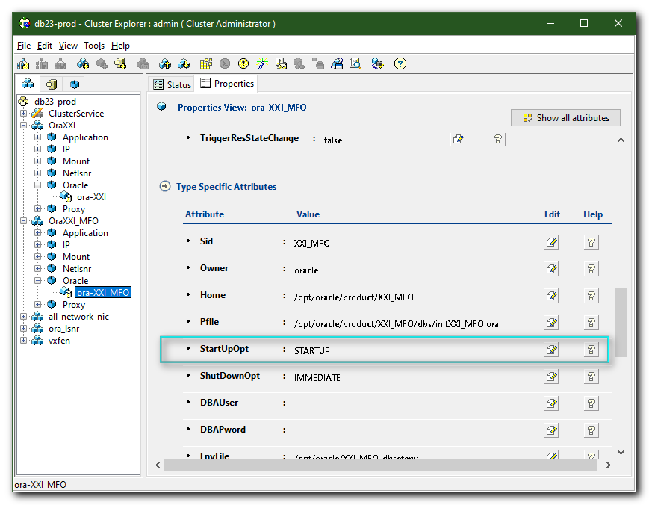
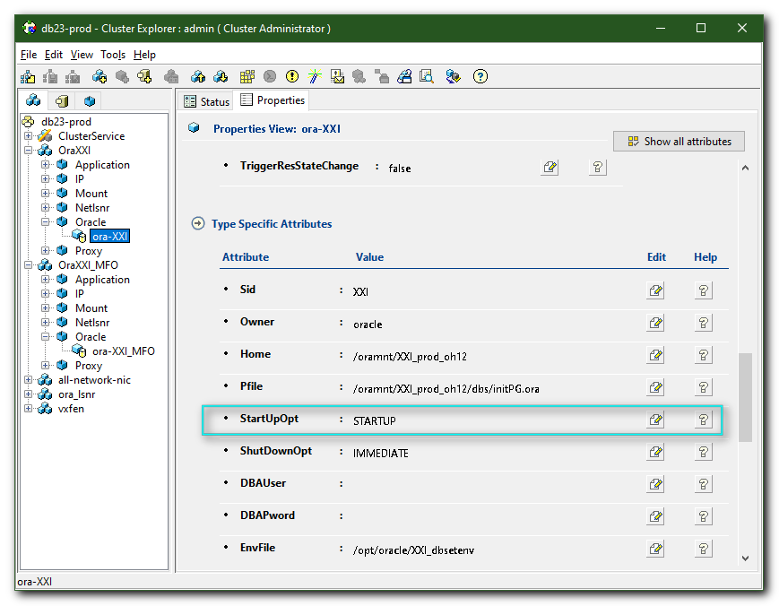

[01:42:13 root@ds-db23-prod1 ~]# tail -f /var/VRTSvcs/log/engine_A.log
2019/09/12 02:02:35 VCS INFO V-16-1-10305 Resource ora-XXI_MFO (Owner: Unspecified, Group: OraXXI_MFO) is offline on ds-db23-prod1 (VCS initiated)
2019/09/12 02:02:35 VCS NOTICE V-16-1-10300 Initiating Offline of Resource ip-XXI_MFO-prod-bgp (Owner: Unspecified, Group: OraXXI_MFO) on System ds-db23-prod1
2019/09/12 02:02:35 VCS NOTICE V-16-1-10300 Initiating Offline of Resource ip-XXI_MFO-prod-dgr (Owner: Unspecified, Group: OraXXI_MFO) on System ds-db23-prod1
2019/09/12 02:02:35 VCS NOTICE V-16-1-10300 Initiating Offline of Resource mnt-XXI_MFO-orahome (Owner: Unspecified, Group: OraXXI_MFO) on System ds-db23-prod1
2019/09/12 02:02:35 VCS NOTICE V-16-1-10300 Initiating Offline of Resource mnt-XXI_MFO-arch (Owner: Unspecified, Group: OraXXI_MFO) on System ds-db23-prod1
2019/09/12 02:02:35 VCS NOTICE V-16-1-10300 Initiating Offline of Resource mnt-XXI_MFO-di01 (Owner: Unspecified, Group: OraXXI_MFO) on System ds-db23-prod1
2019/09/12 02:02:35 VCS NOTICE V-16-1-10300 Initiating Offline of Resource mnt-XXI_MFO-redo (Owner: Unspecified, Group: OraXXI_MFO) on System ds-db23-prod1
2019/09/12 02:02:36 VCS INFO V-16-1-10305 Resource ip-XXI_MFO-prod-dgr (Owner: Unspecified, Group: OraXXI_MFO) is offline on ds-db23-prod1 (VCS initiated)
2019/09/12 02:02:36 VCS INFO V-16-1-10305 Resource ip-XXI_MFO-prod-bgp (Owner: Unspecified, Group: OraXXI_MFO) is offline on ds-db23-prod1 (VCS initiated)
2019/09/12 02:03:44 VCS WARNING V-16-1-50086 Mem usage on ds-db23-prod1 is 82%

[02:10:00 root@ds-db23-prod1 ~]#

[02:10:33 root@ds-db23-prod1 ~]# hastatus -sum | grep -e "XXI_MFO"
B OraXXI_MFO ds-db23-prod1 Y N STOPPING|PARTIAL
B OraXXI_MFO ds-db23-prod2 Y N OFFLINE
B OraXXI_MFO m1-db23-dr Y N OFFLINE
G OraXXI_MFO Mount mnt-XXI_MFO-arch ds-db23-prod1 W_OFFLINE_PROPAGATE
G OraXXI_MFO Mount mnt-XXI_MFO-di01 ds-db23-prod1 W_OFFLINE_PROPAGATE
G OraXXI_MFO Mount mnt-XXI_MFO-orahome ds-db23-prod1 W_OFFLINE_PROPAGATE
G OraXXI_MFO Mount mnt-XXI_MFO-redo ds-db23-prod1 W_OFFLINE_PROPAGATE
[02:10:54 root@ds-db23-prod1 ~]#

[17:52:42 root@m1-db23-dr ~]# lsblk
NAME MAJ:MIN RM SIZE RO TYPE MOUNTPOINT
sdb 8:16 0 1.1T 0 disk
├─sdb1 8:17 0 200M 0 part /boot/efi
├─sdb2 8:18 0 1G 0 part /boot
└─sdb3 8:19 0 1.1T 0 part
├─rootvg-root 253:0 0 50G 0 lvm /
├─rootvg-swap 253:1 0 16G 0 lvm [SWAP]
├─rootvg-opt 253:12 0 500G 0 lvm /opt
├─rootvg-var 253:13 0 100G 0 lvm /var
└─rootvg-tmp 253:14 0 8G 0 lvm /tmp
nvme0n1 259:0 0 2.9T 0 disk
└─nvme0n1p1 259:1 0 2.9T 0 part
├─flashvg-vol01_rmeta_0 253:2 0 4M 0 lvm
│ └─flashvg-vol01 253:6 0 512G 0 lvm /oramnt/flash
├─flashvg-vol01_rimage_0 253:3 0 512G 0 lvm
│ └─flashvg-vol01 253:6 0 512G 0 lvm /oramnt/flash
├─flashvg-vol02_rmeta_0 253:7 0 4M 0 lvm
│ └─flashvg-vol02 253:11 0 2.4T 0 lvm
└─flashvg-vol02_rimage_0 253:8 0 2.4T 0 lvm
└─flashvg-vol02 253:11 0 2.4T 0 lvm
nvme1n1 259:2 0 2.9T 0 disk
└─nvme1n1p1 259:3 0 2.9T 0 part
├─flashvg-vol01_rmeta_1 253:4 0 4M 0 lvm
│ └─flashvg-vol01 253:6 0 512G 0 lvm /oramnt/flash
├─flashvg-vol01_rimage_1 253:5 0 512G 0 lvm
│ └─flashvg-vol01 253:6 0 512G 0 lvm /oramnt/flash
├─flashvg-vol02_rmeta_1 253:9 0 4M 0 lvm
│ └─flashvg-vol02 253:11 0 2.4T 0 lvm
└─flashvg-vol02_rimage_1 253:10 0 2.4T 0 lvm
└─flashvg-vol02 253:11 0 2.4T 0 lvm
[17:52:43 root@m1-db23-dr ~]#

[18:05:08 root@m1-db23-dr ~]# umount /oramnt/flash
[18:22:57 root@m1-db23-dr ~]# lsblk
NAME MAJ:MIN RM SIZE RO TYPE MOUNTPOINT
sdb 8:16 0 1.1T 0 disk
├─sdb1 8:17 0 200M 0 part /boot/efi
├─sdb2 8:18 0 1G 0 part /boot
└─sdb3 8:19 0 1.1T 0 part
├─rootvg-root 253:0 0 50G 0 lvm /
├─rootvg-swap 253:1 0 16G 0 lvm [SWAP]
├─rootvg-opt 253:12 0 500G 0 lvm /opt
├─rootvg-var 253:13 0 100G 0 lvm /var
└─rootvg-tmp 253:14 0 8G 0 lvm /tmp
nvme0n1 259:0 0 2.9T 0 disk
└─nvme0n1p1 259:1 0 2.9T 0 part
├─flashvg-vol01_rmeta_0 253:2 0 4M 0 lvm
│ └─flashvg-vol01 253:6 0 512G 0 lvm
├─flashvg-vol01_rimage_0 253:3 0 512G 0 lvm
│ └─flashvg-vol01 253:6 0 512G 0 lvm
├─flashvg-vol02_rmeta_0 253:7 0 4M 0 lvm
│ └─flashvg-vol02 253:11 0 2.4T 0 lvm
└─flashvg-vol02_rimage_0 253:8 0 2.4T 0 lvm
└─flashvg-vol02 253:11 0 2.4T 0 lvm
nvme1n1 259:2 0 2.9T 0 disk
└─nvme1n1p1 259:3 0 2.9T 0 part
├─flashvg-vol01_rmeta_1 253:4 0 4M 0 lvm
│ └─flashvg-vol01 253:6 0 512G 0 lvm
├─flashvg-vol01_rimage_1 253:5 0 512G 0 lvm
│ └─flashvg-vol01 253:6 0 512G 0 lvm
├─flashvg-vol02_rmeta_1 253:9 0 4M 0 lvm
│ └─flashvg-vol02 253:11 0 2.4T 0 lvm
└─flashvg-vol02_rimage_1 253:10 0 2.4T 0 lvm
└─flashvg-vol02 253:11 0 2.4T 0 lvm
[18:23:00 root@m1-db23-dr ~]#

[18:27:35 root@m1-db23-dr ~]# vgremove flashvg
Do you really want to remove volume group "flashvg" containing 2 logical volumes? [y/n]: y
Do you really want to remove active logical volume flashvg/vol01? [y/n]: y
Logical volume "vol01" successfully removed
Do you really want to remove active logical volume flashvg/vol02? [y/n]: y
Logical volume "vol02" successfully removed
Volume group "flashvg" successfully removed
[18:28:55 root@m1-db23-dr ~]# lsblk
NAME MAJ:MIN RM SIZE RO TYPE MOUNTPOINT
sdb 8:16 0 1.1T 0 disk
├─sdb1 8:17 0 200M 0 part /boot/efi
├─sdb2 8:18 0 1G 0 part /boot
└─sdb3 8:19 0 1.1T 0 part
├─rootvg-root 253:0 0 50G 0 lvm /
├─rootvg-swap 253:1 0 16G 0 lvm [SWAP]
├─rootvg-opt 253:12 0 500G 0 lvm /opt
├─rootvg-var 253:13 0 100G 0 lvm /var
└─rootvg-tmp 253:14 0 8G 0 lvm /tmp
nvme0n1 259:0 0 2.9T 0 disk
└─nvme0n1p1 259:1 0 2.9T 0 part
nvme1n1 259:2 0 2.9T 0 disk
└─nvme1n1p1 259:3 0 2.9T 0 part
[18:29:02 root@m1-db23-dr ~]#

[18:29:02 root@m1-db23-dr ~]# parted /dev/nvme0n1 print
Model: NVMe Device (nvme)
Disk /dev/nvme0n1: 3201GB
Sector size (logical/physical): 512B/512B
Partition Table: gpt
Disk Flags:

Number Start End Size File system Name Flags
1 1049kB 3201GB 3201GB flashvg lvm

[18:31:16 root@m1-db23-dr ~]# parted /dev/nvme1n1 print
Model: NVMe Device (nvme)
Disk /dev/nvme1n1: 3201GB
Sector size (logical/physical): 512B/512B
Partition Table: gpt
Disk Flags:

Number Start End Size File system Name Flags
1 1049kB 3201GB 3201GB flashvg lvm

[18:31:21 root@m1-db23-dr ~]#

#
# If need to remove two partitions I did it with follow command:
# parted /dev/nvme1n1 rm 2 rm 1
#

[18:31:26 root@m1-db23-dr ~]# parted /dev/nvme1n1 rm 1
Information: You may need to update /etc/fstab.

You have new mail in /var/spool/mail/root
[18:32:17 root@m1-db23-dr ~]#

[18:35:03 root@m1-db23-dr ~]# parted /dev/nvme1n1 print
Model: NVMe Device (nvme)
Disk /dev/nvme1n1: 3201GB
Sector size (logical/physical): 512B/512B
Partition Table: gpt
Disk Flags:

Number Start End Size File system Name Flags

[18:35:07 root@m1-db23-dr ~]#

[18:35:07 root@m1-db23-dr ~]# parted -s -a optimal /dev/nvme1n1 mklabel GPT print mkpart primary ext4 0% 100% print
Model: NVMe Device (nvme)
Disk /dev/nvme1n1: 3201GB
Sector size (logical/physical): 512B/512B
Partition Table: gpt
Disk Flags:

Number Start End Size File system Name Flags

Model: NVMe Device (nvme)
Disk /dev/nvme1n1: 3201GB
Sector size (logical/physical): 512B/512B
Partition Table: gpt
Disk Flags:

Number Start End Size File system Name Flags
1 1049kB 3201GB 3201GB primary

[18:35:50 root@m1-db23-dr ~]#

[18:36:11 root@m1-db23-dr ~]# parted /dev/nvme1n1 print
Model: NVMe Device (nvme)
Disk /dev/nvme1n1: 3201GB
Sector size (logical/physical): 512B/512B
Partition Table: gpt
Disk Flags:

Number Start End Size File system Name Flags
1 1049kB 3201GB 3201GB primary

[18:36:19 root@m1-db23-dr ~]#

[18:37:07 root@m1-db23-dr ~]# mkfs.ext4 /dev/nvme1n1p1
mke2fs 1.42.9 (28-Dec-2013)
Discarding device blocks: done
Filesystem label=
OS type: Linux
Block size=4096 (log=2)
Fragment size=4096 (log=2)
Stride=0 blocks, Stripe width=0 blocks
195354624 inodes, 781403904 blocks
39070195 blocks (5.00%) reserved for the super user
First data block=0
Maximum filesystem blocks=2929721344
23847 block groups
32768 blocks per group, 32768 fragments per group
8192 inodes per group
Superblock backups stored on blocks:
32768, 98304, 163840, 229376, 294912, 819200, 884736, 1605632, 2654208,
4096000, 7962624, 11239424, 20480000, 23887872, 71663616, 78675968,
102400000, 214990848, 512000000, 550731776, 644972544

Allocating group tables: done
Writing inode tables: done
Creating journal (32768 blocks): done
Writing superblocks and filesystem accounting information: done

[18:37:25 root@m1-db23-dr ~]#

[18:37:55 root@m1-db23-dr ~]# parted /dev/nvme1n1 print
Model: NVMe Device (nvme)
Disk /dev/nvme1n1: 3201GB
Sector size (logical/physical): 512B/512B
Partition Table: gpt
Disk Flags:

Number Start End Size File system Name Flags
1 1049kB 3201GB 3201GB ext4 primary

[18:38:01 root@m1-db23-dr ~]#

[18:39:28 root@m1-db23-dr ~]# mkdir /oramnt/flash/temp
[18:39:44 root@m1-db23-dr ~]# mount /oramnt/flash/temp
[18:39:49 root@m1-db23-dr ~]#

[18:40:44 root@m1-db23-dr ~]# lsblk -o NAME,TYPE,MOUNTPOINT,FSTYPE,SIZE /dev/nvme0n1 /dev/nvme1n1
NAME TYPE MOUNTPOINT FSTYPE SIZE
nvme0n1 disk 2.9T
└─nvme0n1p1 part LVM2_member 2.9T
nvme1n1 disk 2.9T
└─nvme1n1p1 part /oramnt/flash/temp ext4 2.9T
[18:40:45 root@m1-db23-dr ~]#

[02:57:04 root@ds-db23-prod1 ~]# hastatus -sum | grep -e "XXI" | grep -v -e "MFO"
B OraXXI ds-db23-prod1 Y N STOPPING|PARTIAL
B OraXXI ds-db23-prod2 Y N OFFLINE
B OraXXI m1-db23-dr Y N OFFLINE
G OraXXI Mount mnt-XXI-arch ds-db23-prod1 W_OFFLINE_PROPAGATE
G OraXXI Mount mnt-XXI-base ds-db23-prod1 W_OFFLINE_PROPAGATE
G OraXXI Mount mnt-XXI-di01 ds-db23-prod1 W_OFFLINE_PROPAGATE
G OraXXI Mount mnt-XXI-di02 ds-db23-prod1 W_OFFLINE_PROPAGATE
G OraXXI Mount mnt-XXI-di03 ds-db23-prod1 W_OFFLINE_PROPAGATE
G OraXXI Mount mnt-XXI-di04 ds-db23-prod1 W_OFFLINE_PROPAGATE
G OraXXI Mount mnt-XXI-di05 ds-db23-prod1 W_OFFLINE_PROPAGATE
G OraXXI Mount mnt-XXI-di06 ds-db23-prod1 W_OFFLINE_PROPAGATE
G OraXXI Mount mnt-XXI-di07 ds-db23-prod1 W_OFFLINE_PROPAGATE
G OraXXI Mount mnt-XXI-di08 ds-db23-prod1 W_OFFLINE_PROPAGATE
G OraXXI Mount mnt-XXI-oh12 ds-db23-prod1 W_OFFLINE_PROPAGATE
G OraXXI Mount mnt-XXI-ru ds-db23-prod1 W_OFFLINE_PROPAGATE
[02:57:49 root@ds-db23-prod1 ~]#

[03:04:29 root@ds-db23-prod1 ~]# mount | grep -e "XXI" | egrep -v -e "MFO" | awk '{print $1"\t"$3}'
/dev/nvme1n1p1 /oramnt/flash/XXI_prod_temp
a700-xxi-prod-nfs:/XXI_prod_di01 /oramnt/XXI_prod_di01
a700-xxi-prod-nfs:/XXI_prod_home /opt/oracle/product/XXI
a700-xxi-prod-nfs:/XXI_prod_home/base /oramnt/XXI_prod_base
[03:05:05 root@ds-db23-prod1 ~]#

[03:07:43 root@ds-db23-prod1 ~]# hares -state | grep -e "XXI" | egrep -v -e "MFO" | grep -e "ONLINE"
GxClusterPlugin_OraXXI State ds-db23-prod2 ONLINE
ip-XXI-prod-bgp State ds-db23-prod2 ONLINE
ip-XXI-prod-dgr State ds-db23-prod2 ONLINE
lsnr-XXI State ds-db23-prod2 ONLINE
lsnr-XXI-dgr State ds-db23-prod2 ONLINE
mnt-XXI-arch State ds-db23-prod2 ONLINE
mnt-XXI-base State ds-db23-prod2 ONLINE
mnt-XXI-di01 State ds-db23-prod2 ONLINE
mnt-XXI-di02 State ds-db23-prod2 ONLINE
mnt-XXI-di03 State ds-db23-prod2 ONLINE
mnt-XXI-di04 State ds-db23-prod2 ONLINE
mnt-XXI-di05 State ds-db23-prod2 ONLINE
mnt-XXI-di06 State ds-db23-prod2 ONLINE
mnt-XXI-di07 State ds-db23-prod2 ONLINE
mnt-XXI-di08 State ds-db23-prod2 ONLINE
mnt-XXI-oh12 State ds-db23-prod2 ONLINE
mnt-XXI-ru State ds-db23-prod2 ONLINE
proxy-XXI-dgr State ds-db23-prod1 ONLINE
proxy-XXI-dgr State ds-db23-prod2 ONLINE
proxy-XXI-dgr State m1-db23-dr ONLINE
proxy-XXI-prod State ds-db23-prod1 ONLINE
proxy-XXI-prod State ds-db23-prod2 ONLINE
proxy-XXI-prod State m1-db23-dr ONLINE
proxy-XXI-vNFS State ds-db23-prod1 ONLINE
proxy-XXI-vNFS State ds-db23-prod2 ONLINE
proxy-XXI-vNFS State m1-db23-dr ONLINE
[03:07:46 root@ds-db23-prod1 ~]#

[18:03:17 root@ds-db29-prod1 ~]# hares -state | grep -e "CREDB" | grep -e "ONLINE"
GxClusterPlugin_OraCREDB State ds-db29-prod1 ONLINE
ip-CREDB-prod-bgp State ds-db29-prod1 ONLINE
ip-CREDB-prod-dgr State ds-db29-prod1 ONLINE
lsnr-CREDB State ds-db29-prod1 ONLINE
lsnr-CREDB-dgr State ds-db29-prod1 ONLINE
mnt-CREDB-arch State ds-db29-prod1 ONLINE
mnt-CREDB-di01 State ds-db29-prod1 ONLINE
mnt-CREDB-di02 State ds-db29-prod1 ONLINE
mnt-CREDB-di03 State ds-db29-prod1 ONLINE
mnt-CREDB-di04 State ds-db29-prod1 ONLINE
mnt-CREDB-di05 State ds-db29-prod1 ONLINE
mnt-CREDB-di06 State ds-db29-prod1 ONLINE
mnt-CREDB-di07 State ds-db29-prod1 ONLINE
mnt-CREDB-di08 State ds-db29-prod1 ONLINE
mnt-CREDB-orahome State ds-db29-prod1 ONLINE
mnt-CREDB-ru State ds-db29-prod1 ONLINE
ora-CREDB State ds-db29-prod1 ONLINE
proxy-CREDB-dgr State ds-db29-prod1 ONLINE
proxy-CREDB-dgr State ds-db29-prod2 ONLINE
proxy-CREDB-dgr State m1-db29-dr ONLINE
proxy-CREDB-prod State ds-db29-prod1 ONLINE
proxy-CREDB-prod State ds-db29-prod2 ONLINE
proxy-CREDB-prod State m1-db29-dr ONLINE
proxy-CREDB-vNFS State ds-db29-prod1 ONLINE
proxy-CREDB-vNFS State ds-db29-prod2 ONLINE
proxy-CREDB-vNFS State m1-db29-dr ONLINE
[18:03:27 root@ds-db29-prod1 ~]#

[18:03:27 root@ds-db29-prod1 ~]# hares -state | grep -e "CREDB" | grep -e "OFFLINE"
GxClusterPlugin_OraCREDB State ds-db29-prod2 OFFLINE
GxClusterPlugin_OraCREDB State m1-db29-dr OFFLINE
ip-CREDB-prod-bgp State ds-db29-prod2 OFFLINE
ip-CREDB-prod-bgp State m1-db29-dr OFFLINE
ip-CREDB-prod-dgr State ds-db29-prod2 OFFLINE
ip-CREDB-prod-dgr State m1-db29-dr OFFLINE
lsnr-CREDB State ds-db29-prod2 OFFLINE
lsnr-CREDB State m1-db29-dr OFFLINE
lsnr-CREDB-dgr State ds-db29-prod2 OFFLINE
lsnr-CREDB-dgr State m1-db29-dr OFFLINE
mnt-CREDB-arch State ds-db29-prod2 OFFLINE
mnt-CREDB-arch State m1-db29-dr OFFLINE
mnt-CREDB-di01 State ds-db29-prod2 OFFLINE
mnt-CREDB-di01 State m1-db29-dr OFFLINE
mnt-CREDB-di02 State ds-db29-prod2 OFFLINE
mnt-CREDB-di02 State m1-db29-dr OFFLINE
mnt-CREDB-di03 State ds-db29-prod2 OFFLINE
mnt-CREDB-di03 State m1-db29-dr OFFLINE
mnt-CREDB-di04 State ds-db29-prod2 OFFLINE
mnt-CREDB-di04 State m1-db29-dr OFFLINE
mnt-CREDB-di05 State ds-db29-prod2 OFFLINE
mnt-CREDB-di05 State m1-db29-dr OFFLINE
mnt-CREDB-di06 State ds-db29-prod2 OFFLINE
mnt-CREDB-di06 State m1-db29-dr OFFLINE
mnt-CREDB-di07 State ds-db29-prod2 OFFLINE
mnt-CREDB-di07 State m1-db29-dr OFFLINE
mnt-CREDB-di08 State ds-db29-prod2 OFFLINE
mnt-CREDB-di08 State m1-db29-dr OFFLINE
mnt-CREDB-orahome State ds-db29-prod2 OFFLINE
mnt-CREDB-orahome State m1-db29-dr OFFLINE
mnt-CREDB-ru State ds-db29-prod2 OFFLINE
mnt-CREDB-ru State m1-db29-dr OFFLINE
ora-CREDB State ds-db29-prod2 OFFLINE
ora-CREDB State m1-db29-dr OFFLINE
[18:03:45 root@ds-db29-prod1 ~]#

